**Bunkyo Hydrangea Festival**

General introduction to the Hanami cherry blossom festival

Hanami is a traditional Japanese cherry blossom festival that takes place from March to May every year. This is the time when cherry blossoms bloom all over the streets of Japan, bringing a peaceful, romantic scene and unforgettable experiences to residents and tourists when coming here.

The Hanami Cherry Festival does not have a specific venue. Cherry blossoms in Japan usually bloom from southern Japan first and then to the north. Therefore, this festival is held throughout the land of the rising sun until the end of the season. The Japanese people have marked the cherry blossom tree at Yasukuni Shrine starting to bloom, the new festival officially begins.

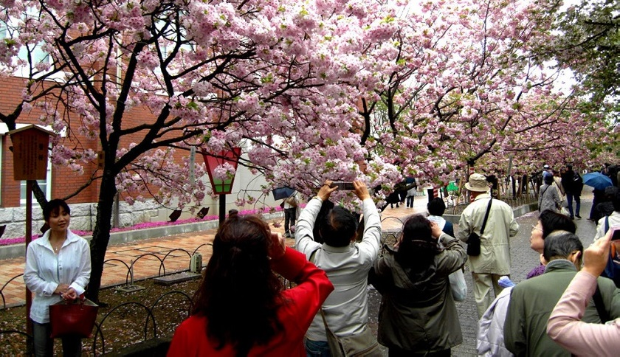

In Japanese, 'hana' means flower, and 'mi' means to watch, so the Hanami festival means simply a flower viewing festival ('flower' here is cherry blossom - the symbol of Japan. Copy). This festival has a long history dating back thousands of years, the time of the festival is also the time when Japanese people and tourists exchange and relax; Families gather together to eat, drink, watch flowers and wish all the best in the new year. These are the great meanings that Hanami festival brings to everyone.

Activities at Hanami Cherry Blossom Festival hội

Cherry blossom viewing

Cherry blossom viewing is the main activity at Hanami festival. Depending on the area, you will choose the appropriate form of flower viewing such as walking or renting a boat to see flowers on the river. In Japan, there are more than 50 different varieties of cherry blossoms. However, they still bloom at the same time, so you will have the opportunity to see many varieties of cherry blossoms with colors such as white, pink, and red.

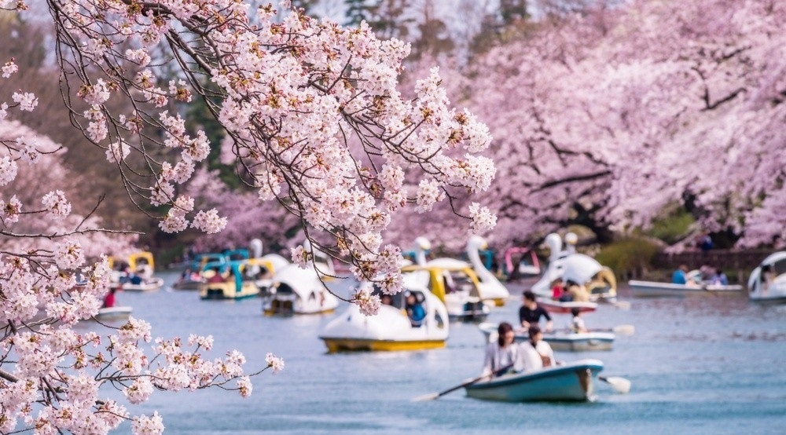

Organize picnic, tea party

At the Hanami festival, you can also choose for yourself a beautiful spot to spread the carpet, display home-prepared dishes and have a very enjoyable short picnic with family and friends. Visitors can go during the day or stay overnight to enjoy the bustling atmosphere here.

Besides, enjoying delicious tea under the cherry blossom tree is also a very popular activity at Hanami festival. Tea is one of the specialties of the country of cherry blossoms, so enjoying a tea party at the cherry blossom festival is a unique cultural feature that you should not miss if you have the opportunity to travel to Japan.

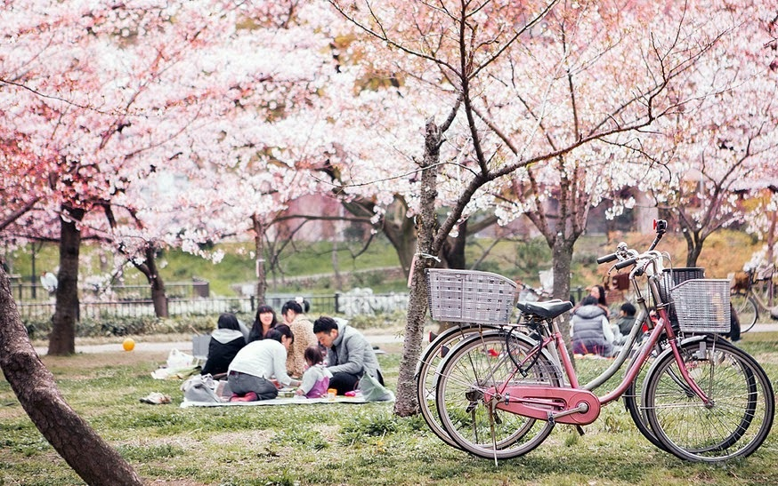

Enjoy Japanese cuisine at the cherry blossom festival

Coming to the Hanami cherry blossom festival, visitors also have the opportunity to explore the cuisine, enjoy the indispensable dishes of the festival such as beautifully decorated bento rice, Hanami dango cake, sakura mochi cake with many varieties. vibrant colors, traditional Japanese sushi, mouth-watering sake or cherry blossom cold noodles,... This will surely be an extremely meaningful experience during your trip to Japan with your family.

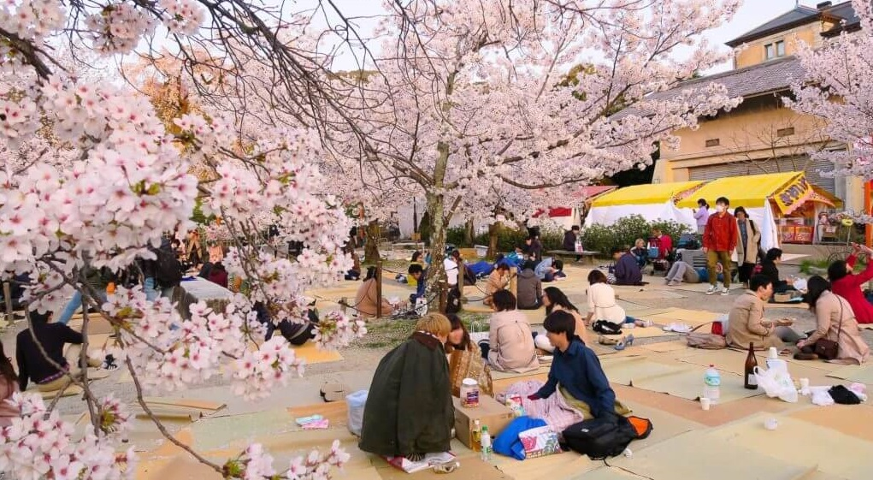

The best places to see cherry blossoms in Japan

In the cold weather and the sun was full, lines of people gathered in gardens and parks where cherry blossoms were planted. Most big cities like Tokyo and Osaka will gather the most people to attend the festival. Let's take a look at some of the most favorite places to see beautiful cherry blossoms in Japan with BestPrice:

Tokyo

In Tokyo, the most beautiful cherry blossom viewing spots are Yasukuni Shrine, Ueno Park, Imperial Palace or Meguro River,... Everyone sits under the canopy of flowers, chats, sings and enjoys some food. Japan is easy to carry on camping trips such as sushi, bento, hanamizake, etc. Kyunaka River in Tokyo is also one of the hottest cherry blossom viewing spots with boating activities on the river to see the flowers, enjoy tea parties.

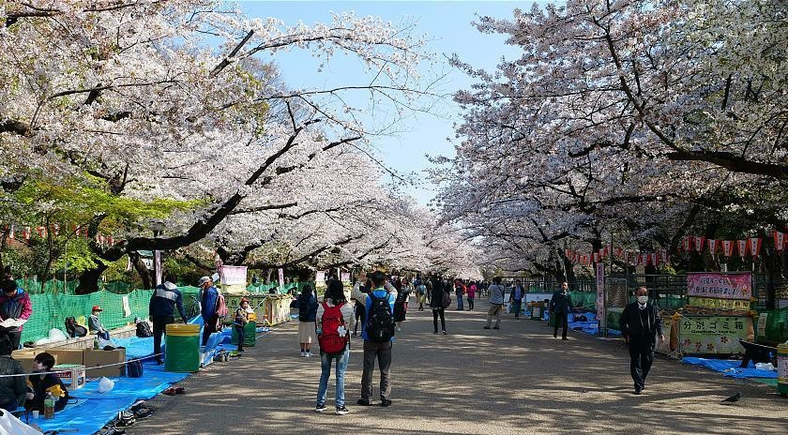

Osaka

In Osaka, residents and visitors often participate in the Hanami festival on the Okawa River - the center of the city. Here you can sit on a boat on the river to watch the cherry blossoms fly all over the two banks of the river very romantic. In addition, Osaka-jo park, EXPO park, Hirakata park, ... are very beautiful cherry blossom viewing spots in Osaka that attract many people to visit.

Kyoto

When visiting Kyoto to participate in the Hanami cherry blossom festival, people often focus on Daigoji Temple, Nijo Castle, Hirano Shrine, Kamogawa River,... These are all very attractive destinations that are often included in the calendar. Japan tour. Coming here during the cherry blossom festival season, visitors will be immersed in a warm space filled with flowers and participate in many interesting activities.

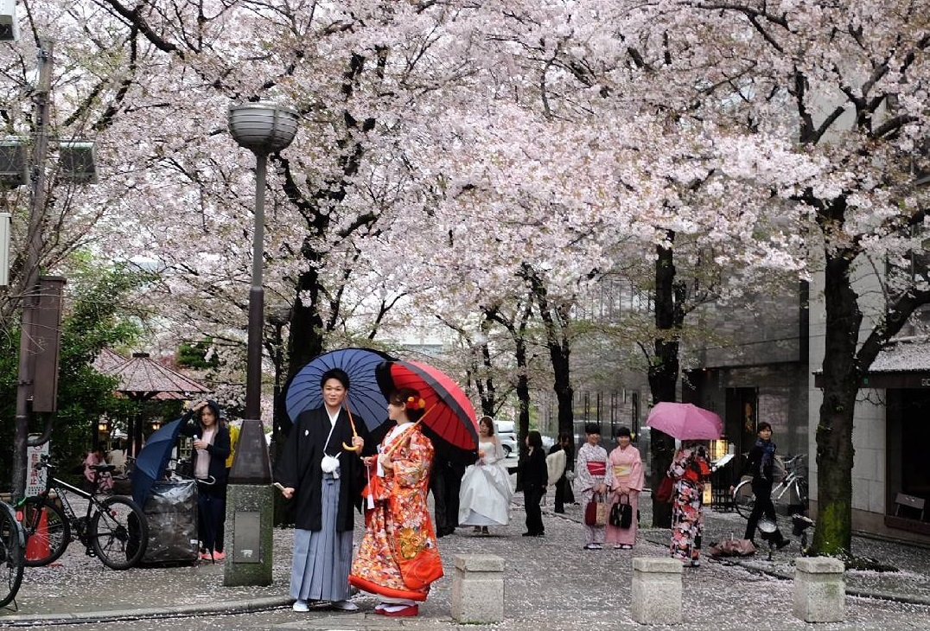

Notes when participating in the Hanami cherry blossom festival

- Join the Hanami festival, you should come early to keep yourself a nice seat to enjoy the scenery. However, don't jostle and jostle with others and just get enough sitting space to see the flowers.

- If you have researched through, you will know that absolutely do not break branches or cut cherry blossoms. This is a tree that is absolutely respected in Japan, if you do not comply, it will be an act of insult to the Japanese.

- Maintain general hygiene and should not drink too much alcohol, alcohol to avoid affecting the bustling atmosphere during the festival.

Above is a summary of all the useful information about the Hanami cherry blossom festival, hopefully the article will help you in your trip to Japan in the coming spring.